Rowantree Primary School
Anti-Bullying Policy
Reviewed August 2025

Ready Safe Respect
It’s ok to make a mistake.
You’re safe.
We love you.
Our ethos:
At Rowantree Primary School, we believe that every member of the school community should feel safe and respected. This policy is designed to support children, staff and parents to recognise, report and address any bullying issues. We aim to promote a caring environment where every child matters and support is given to all. This policy explains the ways in which we work together to ensure a consistent approach to tackling bullying behaviour and how that is embedded in our RRSA journey to gold. We have a school ethos in which bullying is regarded as anti-social behaviour and will not be tolerated.

Our anti-bullying policy aims to:
• Produce a safe and secure environment where all can learn without anxiety and this is at the forefront of school improvement planning (UNCRC and HWB).
• Encourage a positive and caring ethos between adults and children where all feel safe to report any incidents of bullying, know they will be taken seriously and issues dealt with appropriately.
• Raise awareness of the different types of bullying.
• Help children, staff and parents understand the reasons why a child or group of children may become bullies.
• Raise awareness of early signs of distress.
• Ensure all members of the school community are clear about their responsibilities regarding the eradication of bullying in our school.
• Have a consistent approach to bullying throughout the school making clear what is and what is not bullying behaviour.

What is bullying?

Bullying is behaviour that intentionally and persistently causes distress to others.
The definition of bullying is:

“Behaviour by an individual or group usually repeated over time, that intentionally hurts another individual or group either physically or emotionally”.
(Preventing and Tackling Bullying - 2014)

Bullying is both behaviour and impact; the impact is on
a person’s capacity to feel in control of themselves. This
is what we term as their sense of ‘agency’. Bullying takes
place in the context of relationships; it is behaviour that
can make people feel hurt, threatened, frightened and
left out. This behaviour happens face to face and online.
(respectme, 2015)

Resources for the prevention of bullying

We encourage a ‘whole-school approach’ in which children and adults work together to create an environment where everybody gets a clear message that bullying is wrong and will not be tolerated, that bullying behaviour of all kinds must be challenged.

- All school staff, teaching and non-teaching, will be familiar with the Anti-Bullying Policy and procedures for dealing with reports of bullying.
- Awareness raising posters are displayed in classrooms and corridors when staff feel this would have a particular impact (e.g. after a first allegation)
- Appropriate leaflets and literature will be provided for the children when appropriate.
- Children will be encouraged to understand their roles in preventing bullying using, for example, drama; role-play and novels.
- Children will be guided to understand the feelings of bullied children and to practise the skills they need to avoid bullying.
- Online Safety teaching embeds work related to cyber-bullying and how to combat it.
- Peer support is offered from children trained as ‘Playground Buddies’
- Parents will be issued with a copy of the school’s Anti-Bullying policy on our school Seesaw and in paper form if requested. They will be aware of procedures to use if they are concerned that their child is being bullied or does not feel safe to learn.

RRS Principles

• Pupils have a right to learn in a safe and supportive environment, free from intimidation and fear. (Articles 28 & 29)
• The welfare/well-being needs of all children and young people are paramount and pupils’ needs (whether bully or targeted pupil) need to be separated from their behaviour. (Articles 3 & 12)
• When bullying concerns are identified our school will work in a restorative and solution focused way to achieve the necessary change. (Articles 4 & 6)
• Pupils who are targeted will be listened to and supported. (Articles 3 & 12)
• Pupils who engage in bullying behaviour will be listened to and encouraged to accept responsibility and change their behaviour. (Articles 3 & 12)
• Staff will receive awareness-raising training regarding bullying prevention including effective, appropriate strategies for intervention. (Article 3)
• Parents will be made aware of our school’s practice to prevent and to respond to concerns through parent information meetings, consultation processes and where necessary, their active participation in partnership with the school to resolve concerns involving their child. (Article 3)

Forms of bullying

Bullying can take many different forms and is behaviour that intentionally and persistently causes distress to others.
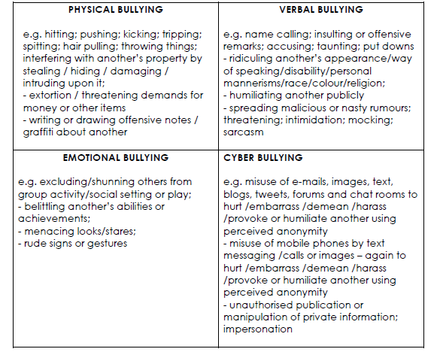

Proactive Strategies to ensure awareness is raised.

• Promote School Ethos at all times.
• Awareness of Rights – UNCRC ( and Responsibilities).
• Recognise and reward good behaviour.
• Use of creative learning to enhance social and emotional skills.
• Ensure that all staff (teaching and non-teaching), parents and pupils and all members of the school community are aware of the school (Positive relationships) Behaviour Policy.
• School assemblies – addressing Bullying and providing Anti-Bullying Strategies.
• Vigilant supervision – playground / general school environment.
• Consultation with School Council.
• Use of Circle time and focussed Health and Wellbeing Curriculum.
• Questionnaires.
• Good parental communication (Seesaw and Twitter).
• Awareness raising e.g. parent meetings, class information meetings, newsletters, social media.
• Awareness of national Anti-Bullying Week (November).
• Classroom displays raising awareness of anti-bullying
• Use of outside agencies – e.g. NSPCC.
• Staff training / effective communication.

Children:

Children are encouraged to report any incidents of bullying or any unacceptable behaviours to an adult in school or at home, whether or not they are directly involved. This can be done verbally or by writing down their concerns, by using our class ‘Speak out’ boxes. In addition, peers within the playground may be approached to support the child to report the incident.

Children who have been bullied will be supported by:

- Offering an immediate opportunity to discuss the experience with a member of staff of their choice.
- Reassuring the child.
- Offering continuous support.t
- Restoring self-esteem and confidence.
- Use of safe space and/or nurture rooms where appropriate.

Children who have bullied will be helped by:

• Discussing honestly what happened and work with the adult to resolve it.
• Discovering why the child became involved.
• Establishing the choice (behaviour) they made and how they could have made a different choice (behaviour).
• Show that they always understand and display appropriate behaviour.
• Informing parents or guardians to help change the attitude of the child and offering continuing support.

Working in partnership with parents:

- Work in partnership with the school.
- Advise their children to report any concerns to a member of staff.
- Discourage behaviours which might be considered as bullying – including online behaviours at home.
- Stress to their children that retaliation is not helpful.
- Contact the school to arrange an appointment with the child’s class teacher and/or SLT to discuss concerns.
- Co-operating with the school, if their child/children are accused of bullying, try to ascertain the truth and point out the implications of bullying, both for the children who are bullied and for the bullies themselves.
- Accept their role in dealing with bullying behaviours which occur outside the school so that they do not interfere with effective learning and teaching during the school day.

Monitoring & Review:

All staff will review the policy on a regular basis and, if necessary, make recommendations for further improvements.
Any incidences of bullying are reported to SLT through ‘Cause for Concern’ forms.
Every year or as appropraite the policy is reviewed. In addition, we use pupil & parent surveys to canvas their views on behaviour, bullying and being safe to inform reviews.

